**ServiceNow API Snippets**

**User Guide**

**Contributors**

Tomoko Shiraishi

Silviu Predan

**Overview**

A few components to perform different actions on the ServiceNow platform using the REST API endpoints. Not an exhaustive implementation but should be considered more as starting point and example on how to use the HTTP Request activity to perform different actions on ServiceNow platform. API automation is faster at run-time compared with traditional UI automation, at the cost of additional learning required for the API endpoints methods and parameters.

We provide snippets for following actions:

1. Download Attachment - DownloadAttachment.xaml
2. Download Task List – DownloadTaskList.xaml
3. Get Attachments List – GetAttachmentsList.xaml
4. Get Record – GetRecord.xaml
5. Get Records – GetRecords.xaml
6. GetRequest Item Variables – GetRequestItemVariables.xaml
7. Update Record – UpdateRecord.xaml

All requests are authenticated using HTTP Basic Authentication with provided Username and Password, which is secure only when secure HTTP is used.

The possible values for the StatusCode returned by the ServiceNow API can be checked in the ServiceNow online documentation following [this link](https://docs.servicenow.com/bundle/madrid-application-development/page/integrate/inbound-rest/reference/r_RESTAPIHTTPResponseCodes.html). In case on non-success response, an exception is thrown from all components.

**Dependencies**

UiPath.WebAPI.Activities [1.4.0]

You can find out how to manage packages in the online Studio documentation at the following link: https://studio.uipath.com/docs/managing-activities-packages#section-managing-packages.

**Compatibility**

Studio　2018.1.3+

**Developer**

Silviu Predan

**Release Date**

March 2019

Table of Contents

Download Attachment 3

Argument List 4

Download Task List 5

Argument List 6

Get Attachments List 7

Argument List 9

Get record 10

Argument List 11

Get Records 12

Argument List 13

Get Request Item Variable 14

Update Record 15

Argument List 17

【Appendix】How to get Query from ServiceNow 18

【Appendix】How to find out ServiceNow table’s names 19

【Appendix】Common ServiceNow tables and internal names 20

【Appendix】ServiceNow useful links 20

# Download Attachment - DownloadAttachment.xaml

This workflow gets the binary file attachment with a specific ID value and saves it in the specified file path.

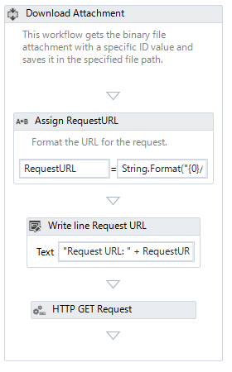

**➁**

**➀**

|  |  |  |
| --- | --- | --- |
| **Item** | **Activity** | **Description** |
| 1. Assign Request URL | Assign | Format the URL for the request: https://<instance>.servicenow.com/api/now/attachment/<AttachmentID>/file |
| 1. HTTP GET Request | HttpClient | Http Get Request to download the resource specified by AttachmentID to a local file specified by FilePath argument. The request is authenticated using provided Username and Password.  StatusCode of 200 means that the request was accepted and processed by the remote server. |

## Argument List

|  |  |  |  |
| --- | --- | --- | --- |
| **Name** | **Direction** | **Argument type** | **Description** |
| in_InstanceURL | InArgument | String | ServiceNow instance URL |
| in_Username | InArgument | String | Login Username |
| in_Password | InArgument | String | Login Password |
| in_AttachementID | InArgument | String | The identifier (sys_id) of the attachment record you want to get binary data from |
| in_FilePath | InArgument | String | Filepath where to download files and Filename |
| in_TimeoutMS | InArgument | Int32 | The maximum time, in milliseconds, to wait for the HTTP request to complete. |

# Download Task List - DownloadTaskList.xaml

Download the tasks filtered by specified criteria in one of the supported output formats. Parameters array can be used to specify different filtering criteria. The output file can be in different formats, such as XLSX, XLS, PDF, CSV. Other formats are supported by ServiceNow API, but not implemented or tested with this workflow.

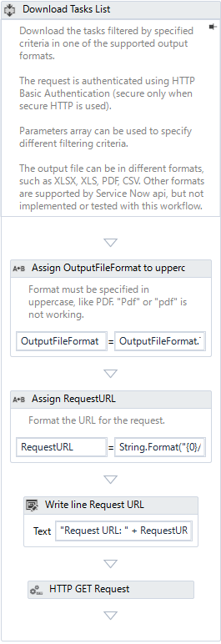

**➀**

**➁**

**➂**

|  |  |  |
| --- | --- | --- |
| **Item** | **Activity** | **Description** |
| 1. Assign OutputFileFormat to uppercase | Assign | Format must be specified in uppercase, like PDF. "Pdf" or "pdf" is not working. |
| 1. Assign RequestURL | Assign | Format the URL for the request: https://<instance>.servicenow.com/ <TaskListEndpoint>?XLSX&sysparm_query=<query> |
| 1. HTTP GET Request | HttpClient | HTTP Get request to download the report filtered by provide query in one of the supported formats. |

## Argument List

|  |  |  |  |
| --- | --- | --- | --- |
| **Name** | **Direction** | **Argument type** | **Description** |
| in_InstanceURL | InArgument | String | ServiceNow instance URL. |
| in_Username | InArgument | String | Login Username |
| in_Password | InArgument | String | Login password |
| in_OutputFileFormat | InArgument | String | Specify the file format for the downloaded report.  Supported values:  - XLSX  - XLS (or EXCEL)  - PDF  - CSV |
| in_OutputFilePath | InArgument | String | Full or relative file path to save the downloaded report. |
| in_Query | InArgument | String | List of query parameters.  The value can be found by applying all filters in Service Now web interface and then right click on last condition -> Copy query. |
| in_TimeoutMS | InArgument | Int32 | The maximum time, in milliseconds, to wait for the HTTP request to complete. |

# Get Attachments List - GetAttachmentsList.xaml

This workflow gets the attachments list for a record in a given table.

The output if formated as a DataTable with 4 columns:

* sys_id – ID of the attachment
* file_name – file name for the attachment
* content_type – file type for the attachment
* size_bytes – attachment file size in bytes.

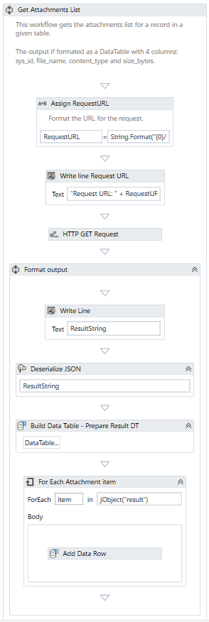

**➀**

**➁**

**➂**

|  |  |  |
| --- | --- | --- |
| **Item** | **Activity** | **Description** |
| 1. Assign RequestURL | Assign | Format the URL for the request: https://<instance>.servicenow.com/ api/now/attachment?sysparm_query=<TableName>^table_sys_id=<RecordId>^sysparm_limit=<Limit> |
| 1. HTTP GET Request | HttpClient | Http Get Request to retrieve the list of attachments for a given record in a specified table. |
| 1. Format output | Sequence | Data is extracted from the JSON response and added in the output argument of type DataTable. |

## Argument List

|  |  |  |  |
| --- | --- | --- | --- |
| **Name** | **Direction** | **Argument type** | **Description** |
| in_TableName | InArgument | String | The name of the table of the specified record you want to get attachments list. |
| in_RecordId | InArgument | String | The ID of the record to get the list of attachments. |
| in_Limit | InArgument | Int32 | Maximum number of results to return. |
| in_InstanceURL | InArgument | String | ServiceNow instance URL |
| in_Username | InArgument | String | Login Usersame |
| in_Password | InArgument | String | Login Password |
| out_Result | OutArgument | DataTable | DataTable of Attachment list |
| in_TimeoutMS | InArgument | Int32 | The maximum time, in milliseconds, to wait for the HTTP request to complete. |

# Get record - GetRecord.xaml

This method retrieves details about the record identified by the specified identifier from the given table. The display values are returned, instead of the internal values.

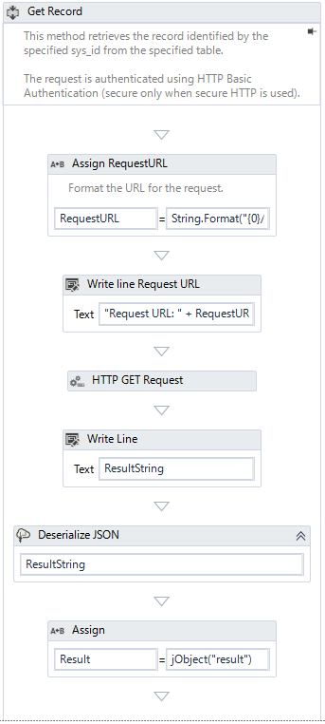

**➀**

**➁**

**➂**

**➃**

|  |  |  |
| --- | --- | --- |
| **Item** | **Activity** | **Description** |
| 1. Assign RequestURL | Assign | Format the URL for the request: https://<instance>.servicenow.com/ /api/now/table/<TableName>/<RecordID> |
| 1. HTTP GET Request | HttpClient | Http Get Request to retrieve the specified record from the table. The Display Values are returned, instead of internal values, by setting "sysparm_display_value" parameter to "True".  The reference links are not returned, by setting "sysparm_exclude_reference_link" parameter to "True". |
| 1. Deserialize JSON | DeserializeJson<JObject> | Deserializes the JSON string to a JObject |
| 1. Assign | Assign | Extract the “result” part of the JSON object as the Result of the workflow. |

## Argument List

|  |  |  |  |
| --- | --- | --- | --- |
| **Name** | **Direction** | **Argument type** | **Description** |
| in_InstanceURL | InArgument | String | ServiceNow instance URL |
| in_Username | InArgument | String | Login Usersame |
| in_Password | InArgument | String | Login Password |
| in_TableName | InArgument | String | The name of the table of the specified record you want to get record |
| out_Result | OutArgument | JToken | JToken of Record |
| in_RecordID | InArgument | String | Unique identifier of the record to retrieve |
| in_TimeoutMS | InArgument | Int32 | The maximum time, in milliseconds, to wait for the HTTP request to complete. |

# Get Records - GetRecords.xaml

Retrieves multiple records for the specified table filtered by specified criteria.

To find out the value needed by the Query parameter, you can filter the table as required in the Service Now website and then right click on the last filter and select "Copy query". OutputFields is an array with the fields that are retrieved from the webservice, corresponding to the ServiceNow sysparm_fields parameter.

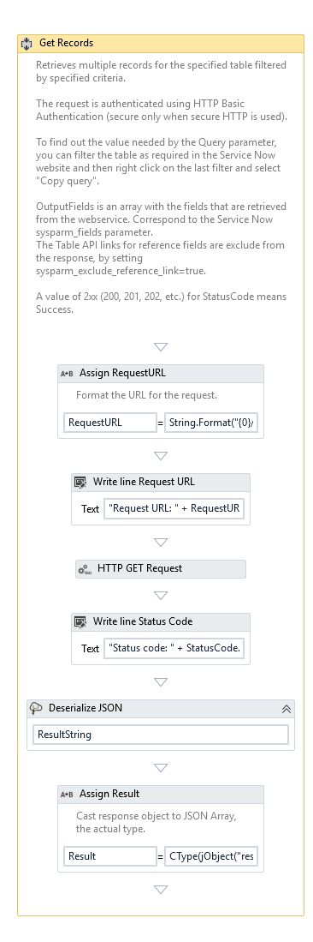

**➀**

**➁**

**➂**

**➃**

|  |  |  |
| --- | --- | --- |
| **Item** | **Activity** | **Description** |
| 1. Assign RequestURL | Assign | Format the URL for the request: https://<instance>.servicenow.com/ /api/now/table/<TableName>?sysparm_query=<Query> |
| 1. HTTP GET Request | HttpClient | Http Get Request to retrieve the list of records for the given table and filtering query. The fields retrieved for each record is set using the sysparm_fields parameter, mapped from input argument OutputFields. |
| 1. Deserialize JSON | DeserializeJson<JObject> | Deserializes the JSON string to a JObject |
| 1. Assign Result | Assign | The list of records is found in the “result” field of the JSON object but it needs to be converted to JArray. |

## Argument List

|  |  |  |  |
| --- | --- | --- | --- |
| **Name** | **Direction** | **Argument type** | **Description** |
| in_InstanceURL | InArgument | String | ServiceNow instance URL |
| in_Username | InArgument | String | Login Usersame |
| in_Password | InArgument | String | Login Password |
| in_Query | InArgument | String | List of query parameters.  You can easily find this string by applying all filters in Service Now web interface and then right click on last condition -> Copy query. |
| in_TableName | InArgument | String | Name of the table from which to retrieve the records. |
| out_Result | OutArgument | JArray |  |
| in_OutputFields | InArgument | String Array |  |
| in_TimeoutMS | InArgument | Int32 | The maximum time, in milliseconds, to wait for the HTTP request to complete. |

# Get Request Item Variable - GetRequestItemVariables.xaml

This method retrieves the variables for a given request item. Only the variable name (internal) and value are retrieved. Uses the GetRecords.xaml workflow configured for the Variables table (sc_item_option_mtom), the query parameter for Request Item filtering and the output includes only two fields - variable's name and value.

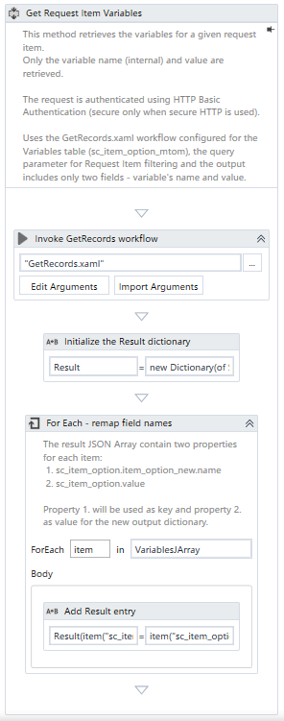

**➀**

**➁**

|  |  |  |
| --- | --- | --- |
| **Item** | **Activity** | **Description** |
| 1. Invoke GetRecords workflow | InvokeWorkflowFile | Get Records from *Get Records* component |
| 1. For Each - remap field names | ForEach<JToken> | The result JSON Array contain two properties for each item:  1. sc_item_option.item_option_new.name  2. sc_item_option.value  Property 1. will be used as key and property 2. as value for the new output dictionary. |

**Argument List**

|  |  |  |  |
| --- | --- | --- | --- |
| **Name** | **Direction** | **Argument type** | **Description** |
| in_InstanceURL | InArgument | String | ServiceNow instance URL, for example "https://dev123.servicenow.com". |
| in_Username | InArgument | String | Login Usersame |
| in_Password | InArgument | String | Login Password |
| out_Result | OutArgument | JArray |  |
| in_RequestItemID | InArgument | String | Unique identifier of the Request Item for which to retrieve the variables. |
| in_Query | InArgument | String | List of query parameters.  You can easily find this string by applying all filters in Service Now web interface and then right click on last condition -> Copy query. |
| in_TableName | InArgument | String | Name of the table from which to retrieve the records. |
| in_OutputFields | InArgument | String Array |  |

# Update Record - UpdateRecord.xaml

This workflow updates the specified record with the new data contained in the input DataTable object. At least two columns are required, first column is used for field name and the second column is used for new value. The response body is suppressed using the "X-no-response-body" header, as it is not required.

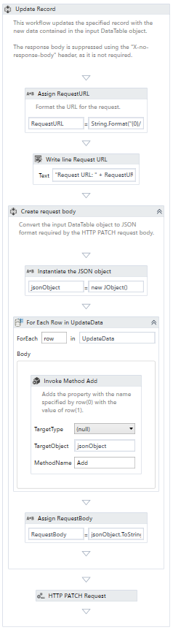

**➀**

**➁**

**➂**

|  |  |  |
| --- | --- | --- |
| **Item** | **Activity** | **Description** |
| 1. Assign RequestURL | Assign | Format the URL for the request: https://<instance>.servicenow.com/ /api/now/table/<TableName>/<RecordID> |
| 1. Create request body | Sequence | Converts the input DataTable object to the JSON format required for the HTTP PATCH request body. |
| 1. HTTP PATCH Request | HttpClient | The HTTP request to update the specified record using the new data from the input DataTable. |

## Argument List

|  |  |  |  |
| --- | --- | --- | --- |
| **Name** | **Direction** | **Argument type** | **Description** |
| in_InstanceURL | InArgument | String | ServiceNow instance URL, for example "https://dev123.servicenow.com". |
| in_Username | InArgument | String | Login Username |
| in_Password | InArgument | String | Login password |
| in_TableName | InArgument | String | Name of the table in which the record is located |
| in_RecordID | InArgument | String | Unique identifier of the record to update |
| in_UpdateData | InArgument | DataTable | DataTable object with the fields and new values to update. At least two columns are required, first column is used for field name and the second column is used for new value. |
| in_TimeoutMS | InArgument | Int32 | The maximum time, in milliseconds, to wait for the HTTP request to complete. |

# 【Appendix】How to get Query from ServiceNow

1. Go to the target page and apply all required filters

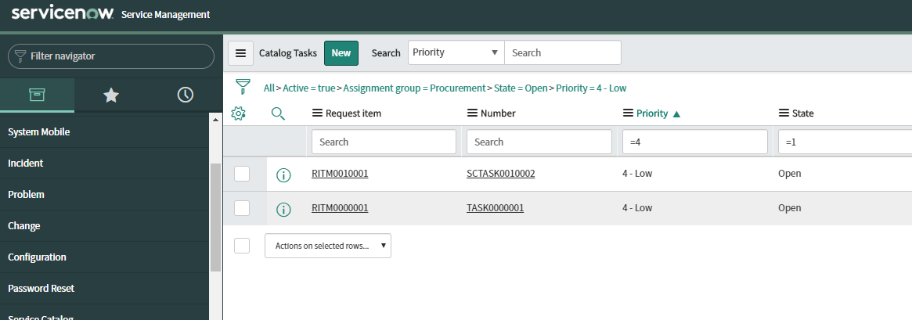

1. Right Click on the last item

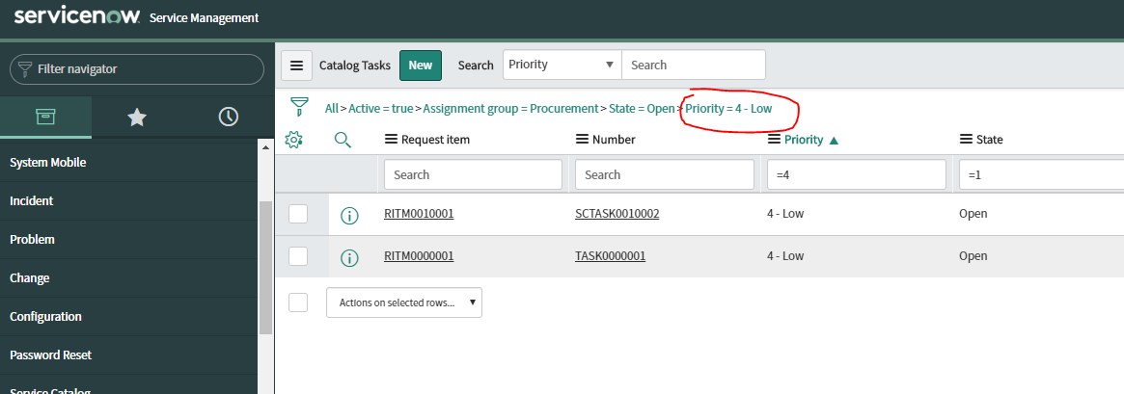

1. Click “Copy query”

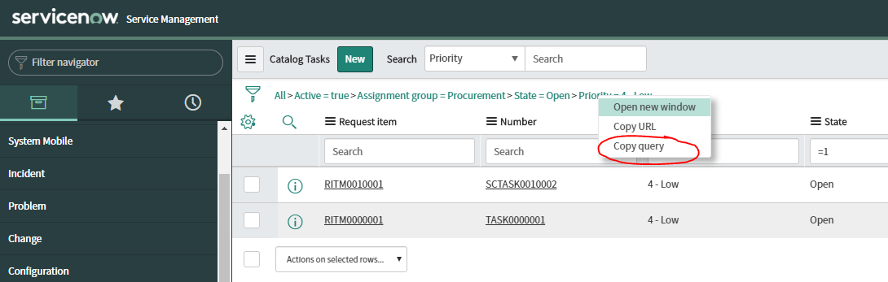

1. You will be able to get following query

active=true^assignment_group=8a4cb6d4c61122780043b1642efcd52b^state=1^priority=4

# 【Appendix】How to find out ServiceNow table’s names

Method 1: **Using the Tables & Columns application.**

*Note: admin permissions are required.*

Steps:

1. Locate the Tables & Columns application, under System Definitions.
2. Select (click) the table that you are interested in.
3. The internal table name is shown in the “Table name” field.
4. Details about the available fields in the selected table are shown in the right side.

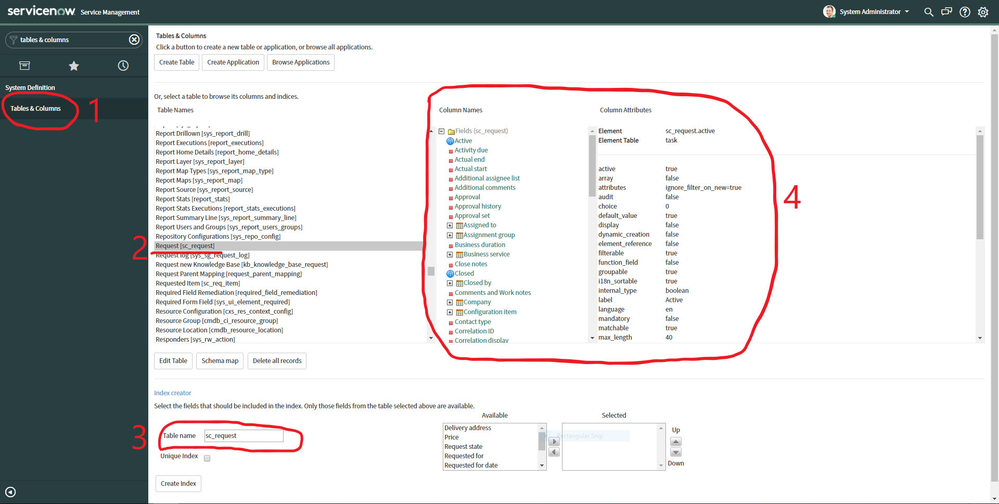

Method 2: **Inspect the endpoint in the button link url**.

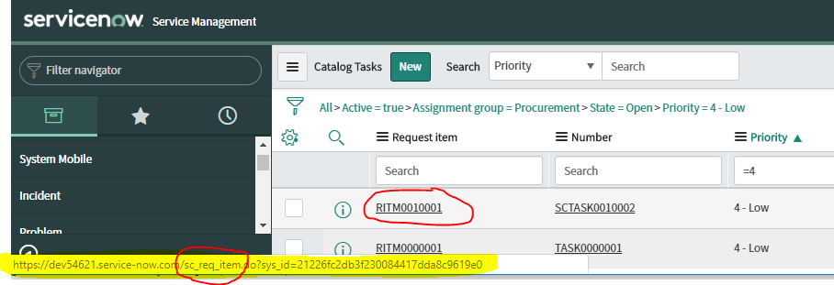

# 【Appendix】Common ServiceNow tables and internal names

|  |  |
| --- | --- |
| Display Name | Internal Name |
| Catalog Task | sc_task |
| Change Task | change_task |
| Change Request | change_request |
| Request | sc_request |
| Requested Item | sc_req_item |
| Variable Ownership | sc_item_option_mtom |
| Incident | incident |
| Catalog | sc_catalog |
| Catalog Item | sc_cat_item |
| Catalog Item Category | sc_cat_item_category |
| Category | sc_category |

# 【Appendix】ServiceNow useful links

* <https://developer.servicenow.com/app.do#!/program/developer> - ServiceNow Developer Program homepage.
* <https://developer.servicenow.com/app.do#!/documentation?v=madrid> – Developer specific documentation for ServiceNow, covering best practices, tutorials and examples.
* <https://developer.servicenow.com/app.do#!/rest_api_doc?v=madrid> – the REST API documentation